Students :

1 - Ahmed Wael Said ID : 2091 [Load - Insert - Search - Delete - Validations]

2 - Mohamed Hegazy ID : 2204 [Validations - Search - Report]

3 - Mohamed Mahmoud ID:2211 [Delete - Save - Print - Report]

-------------------------------------------------------------------------------------------------------------

PROJECT REPORT

Statement :-

- This project shows the implementation of the binary search trees.

- The program enables the user to perform many actions as following :-

1 - Load information from file to the tree.

2 - Insert a new student to the tree.

3 - Search for a certain student in the tree.

4 - Delete a student from the tree.

5 - Print all the students in the tree.

6 - Exit the program.

-------------------------------------------------------------------------------------------------------------

HOW THE MAIN METHOD WORKS :-

- The user is asked to enter the choice of the action he wants to perform as shown in the screenshot below.

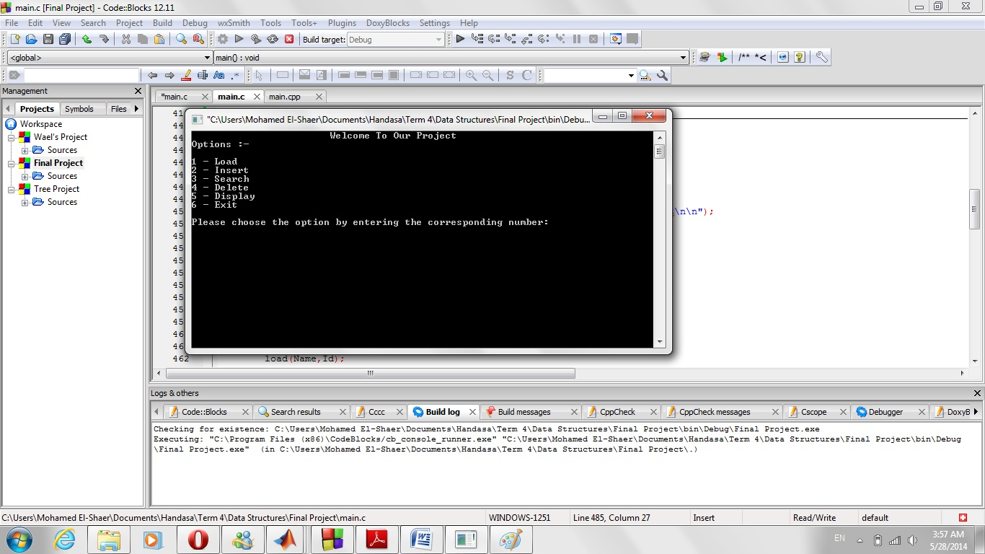

- If the user demanded to use Delete or Search or Print, A new sub menu appears asking him/her about the method of performing this action.

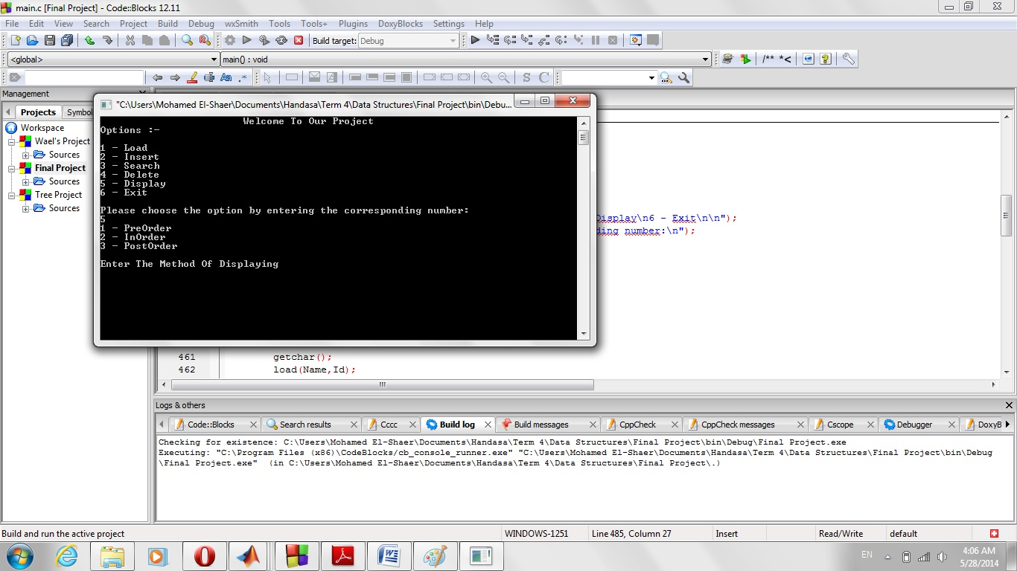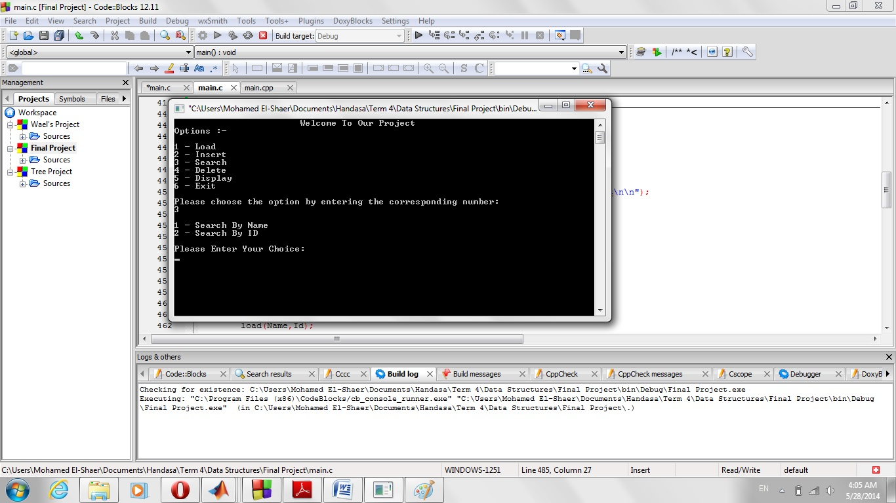

- When the user chooses to load information from file, he is asked to enter the name of the file and the extension of this file (ex : names.txt).

- The Insert function enables the user to enter a new student into the tree.

- Search function allows the user to look for a certain student either by his name or by his ID.

- Delete function allows the user to remove a certain contact from the tree.

- Display function prints all the student of the tree in three ways :-

1 - PreOrder : Root then Left then Right.

2 - InOrder : Left then Root then Right.

3 - PostOrder : Left then Right then Root.

- Exit function ends the program.

­-------------------------------------------------------------------------------------------------------------

Test cases :-

-Our Program gets its information from an external file.

-This file contains 2 fields : Name and ID.

-The file we used is called names.txt.

-this file contains 3 students represented as :

mohamed mahmoud,2211

ahmed wael,2091

mohamed hegazy,2204